Gender Data Compass 2023 Report Title

DRAFT

# The Gender Data Compass charts the course towards gender data systems that work for all.

Behind every good decision is information that sheds light on a problem. High-quality and timely data on the right questions are crucial to informed policies and actions. Gender impacts every facet of society: education, employment and pay, access to healthcare, and political participation. Data that sheds light on the distinct experiences of men and women will help address blind spots and accelerate progress towards a more equitable world. But the availability, access, and support for gender data is still inadequate. Nearly half the data we need to measure and monitor gender equality remains unavailable at the country-level.

The Gender Data Compass (GDC) offers guidance to national statistical offices to help strengthen national gender data systems and their enabling environments. It reveals the current state of availability and openness of 53 indicators from economic empowerment and education to health and environment in over 180 countries. It sheds light on critical questions that countries need to understand to chart a course towards improvement. What official statistics are available and what are missing to understand and address issues of gender equality? Are these data accessible and open to all?

And what of the support needed to sustain robust gender data systems? The GDC also explores the questions around the landscape needed for these systems. Does a country have policies and laws to aid the generation and openness of official gender data? Is the regulatory framework, funding landscape, and national capacity strong enough to drive the transformation we seek? These issues are crucial to understanding the deeper context in which improvements can occur.

**Figure 1: The five dimensions of the Gender Data Compass**

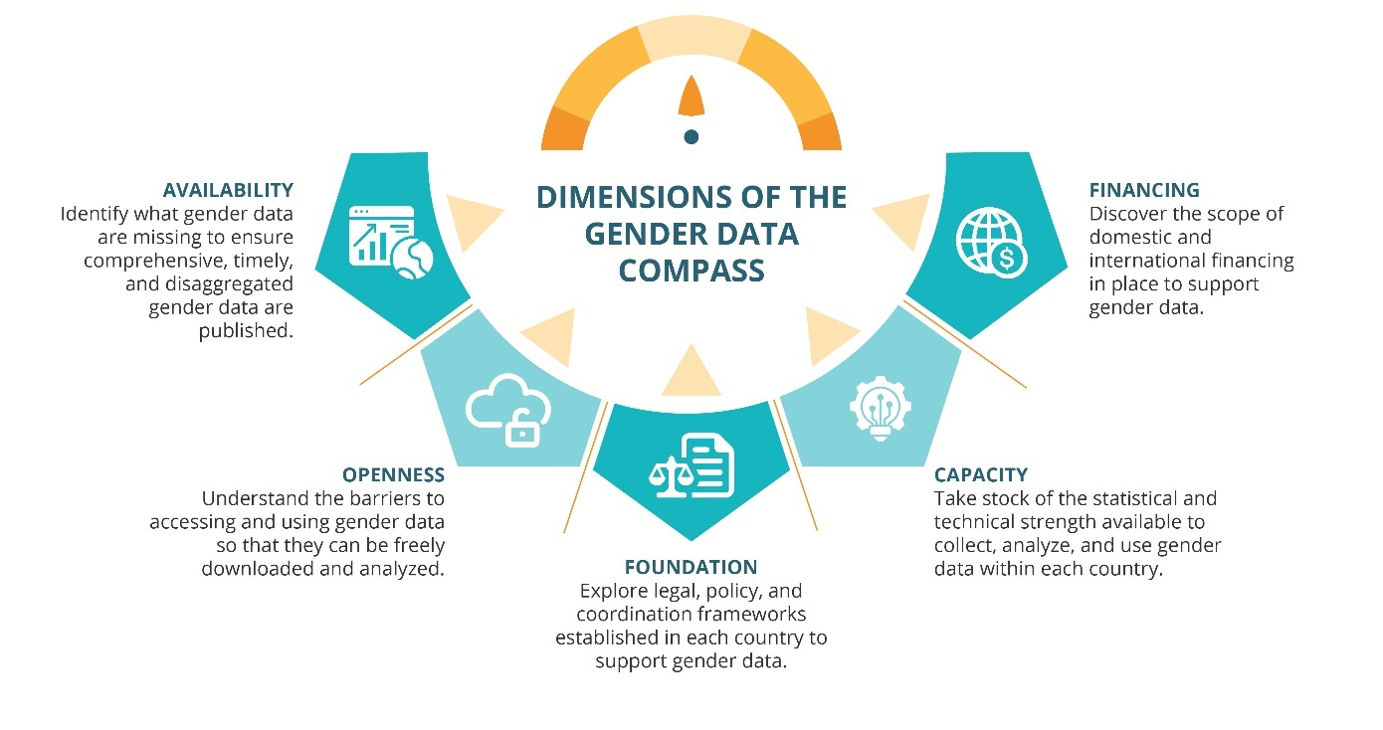

While gender data might not be the sole ingredient needed to achieve gender equality around the world, it is absolutely crucial to ensuring that decisions can be well-informed and driven by the right high-quality data. In a world with so many conflicting interests and murky challenges, understanding the reality of a problem and its different facets is a crucial starting point in achieving any sort of progress. Gender data can help reveal our shared reality and both inform and strengthen arguments for where and how action needs to occur. The GDC serves as a powerful tool to help countries ensure that the data needed to inform these crucial processes is available, accessible, and well supported.

# [1] What is the state of open gender data?

Lorem ipsum dolor sit amet, consectetuer adipiscing elit, sed diam nonummy nibh euismod tincidunt ut laoreet dolore magna aliquam erat volutpat. Ut wisi enim ad minim veniam, quis nostrud exerci tation ullamcorper suscipit lobortis nisl ut aliquip ex ea commodo consequat, vel illum dolore eu feugiat nulla facilisis at vero eros et accumsan et iusto odio dignissim qui blandit praesent luptatum zzril delenit augue duis dolore te feugait nulla facilisi.

**Figure 2: GDC Overall Scores, 2023**

Lorem ipsum dolor sit amet, consectetuer adipiscing elit, sed diam nonummy nibh euismod tincidunt ut laoreet dolore magna aliquam erat volutpat. Ut wisi enim ad minim veniam, quis nostrud exerci tation ullamcorper suscipit lobortis nisl ut aliquip ex ea commodo consequat, vel illum dolore eu feugiat nulla facilisis at vero eros et accumsan et iusto odio dignissim qui blandit praesent luptatum zzril delenit augue duis dolore te feugait nulla facilisi.

**Figure 3: Average scores for the five dimensions, 2023**

Lorem ipsum dolor sit amet, consectetuer adipiscing elit, sed diam nonummy nibh euismod tincidunt ut laoreet dolore magna aliquam erat volutpat. Ut wisi enim ad minim veniam, quis nostrud exerci tation ullamcorper.

**Table 1: Average overall scores by region, 2023**

|  |  |
| --- | --- |
| **Region** | **Average Overall Score** |
| Northern Europe | 48.5 |
| North America | 40.9 |
| Australia and New Zealand | 38.7 |
| Eastern Europe | 38.0 |
| South America | 35.8 |
| Western Asia | 35.4 |
| Southern Europe | 34.1 |
| Central Asia | 33.2 |
| South-Eastern Asia | 32.7 |
| Western Europe | 31.6 |
| Eastern Asia | 31.5 |
| Western Africa | 28.8 |
| Central America | 28.8 |
| Southern Africa | 27.6 |
| Eastern Africa | 27.5 |
| Southern Asia | 26.3 |
| Northern Africa | 24.0 |
| Middle Africa | 21.3 |
| Pacific Islands | 18.9 |
| Caribbean | 18.1 |

# [2] Where are the gender data gaps?

Throughout the world, [%] of crucial gender data are missing. Comprehensive availability of gender data is crucial for developing effective policies and tracking progress towards achieving gender equality. Without enough data, it is impossible to identify where the needs are greatest and what impact efforts have had to improve various issues. Availability of gender data is more than having a single data point. The right indicators need to be published with enough detail so that they can be effectively used. For example, to fully understand critical health issues, cause of death for men and women need to be further broken down by age, geographic location, and other factors. And to be truly useful, multiple years of data are needed to show how an issue evolves over time, and recent years are needed to show what the current situation is. With comprehensive, timely, and disaggregated gender data, countries are empowered to understand issues and improve lives.

## Lorem ipsum dolor sit amet, consectetuer adipiscing elit

Lorem ipsum dolor sit amet, consectetuer adipiscing elit, sed diam nonummy nibh euismod tincidunt ut laoreet dolore magna [aliquam erat volutpat](placeholder). Ut wisi enim ad minim veniam, quis nostrud exerci tation ullamcorper suscipit lobortis nisl ut aliquip ex ea commodo consequat, vel illum **dolore eu feugiat[1]** nulla facilisis at vero eros et accumsan et iusto odio dignissim qui blandit praesent luptatum zzril delenit augue duis dolore te feugait nulla facilisi.

**Figure 4: Coverage subscores by data category, 2023**

|  |
| --- |
| **Country Spotlight: [Country Name]**  Lorem ipsum dolor sit amet, consectetuer adipiscing elit, sed diam nonummy nibh euismod tincidunt ut laoreet dolore magna aliquam erat volutpat. Ut wisi enim ad minim veniam, quis nostrud exerci tation ullamcorper suscipit lobortis nisl ut aliquip ex ea commodo consequat, vel illum dolore eu feugiat nulla facilisis at vero eros et accumsan et iusto odio dignissim qui blandit praesent luptatum zzril delenit augue duis dolore te feugait nulla facilisi. |

## Lorem ipsum dolor sit amet, consectetuer adipiscing elit

Lorem ipsum dolor sit amet, consectetuer adipiscing elit, sed diam nonummy nibh euismod tincidunt ut laoreet dolore magna aliquam erat volutpat. Ut wisi enim ad minim veniam, quis nostrud exerci tation ullamcorper suscipit lobortis nisl ut aliquip ex ea commodo consequat, vel illum dolore eu feugiat nulla facilisis at vero eros et accumsan et iusto odio dignissim qui blandit praesent luptatum zzril delenit augue duis dolore te feugait nulla facilisi.

**Figure 5: Coverage element subscores for all data categories, 2023**

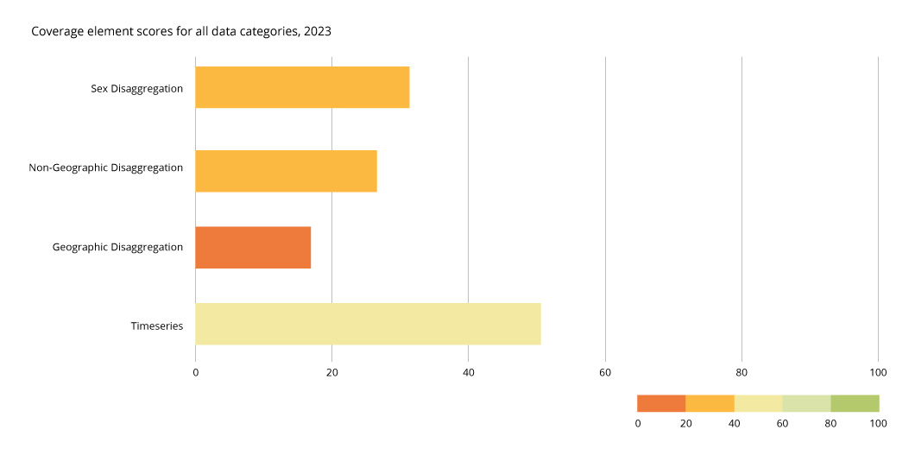

|  |
| --- |
| **Country Spotlight: [Country Name]**  Lorem ipsum dolor sit amet, consectetuer adipiscing elit, sed diam nonummy nibh euismod tincidunt ut laoreet dolore magna aliquam erat volutpat. Ut wisi enim ad minim veniam, quis nostrud exerci tation ullamcorper suscipit lobortis nisl ut aliquip ex ea commodo consequat, vel illum dolore eu feugiat nulla facilisis at vero eros et accumsan et iusto odio dignissim qui blandit praesent luptatum zzril delenit augue duis dolore te feugait nulla facilisi. |

## Lorem ipsum dolor sit amet, consectetuer adipiscing elit

Lorem ipsum dolor sit amet, consectetuer adipiscing elit, sed diam nonummy nibh euismod tincidunt ut laoreet dolore magna aliquam erat volutpat. Ut wisi enim ad minim veniam, quis nostrud exerci tation ullamcorper suscipit lobortis nisl ut aliquip ex ea commodo consequat, vel illum dolore eu feugiat nulla facilisis at vero eros et accumsan et.

**Table 2: Least available indicators by sex, 2023**

|  |  |  |
| --- | --- | --- |
| **Indicators** | **Percent of countries that do not publish by sex** | **Percent of countries that do not publish at all** |
| Child immunization | 40.5 | 22.7 |
| Mobile phone usage | 40 | 13.5 |
| Disease prevalence | 38.4 | 10.3 |
| Poverty | 37.3 | 17.3 |
| Internet usage | 37.3 | 10.3 |
| Mortality due to natural disasters | 30.8 | 63.2 |
| Marriage registration | 30.3 | 28.6 |
| Food insecurity | 28.1 | 59.5 |
| Births | 25.4 | 2.7 |
| Child mortality | 24.3 | 8.6 |
| Mortality due to pollution | 23.8 | 58.9 |
| Homicides | 23.8 | 29.7 |
| Access to financial resources | 20 | 51.9 |

Lorem ipsum dolor sit amet, consectetuer adipiscing elit, sed diam nonummy nibh euismod tincidunt ut laoreet dolore magna aliquam erat volutpat. Ut wisi enim ad minim veniam, quis nostrud exerci tation ullamcorper suscipit lobortis nisl ut aliquip ex ea commodo consequat, vel illum dolore eu feugiat nulla facilisis at vero eros et accumsan et iusto odio dignissim qui blandit praesent luptatum zzril delenit augue duis dolore te feugait nulla facilisi.

**Figure 6: Availability of additional disaggregations for sex-disaggregated datasets versus non sex-disaggregated datasets**

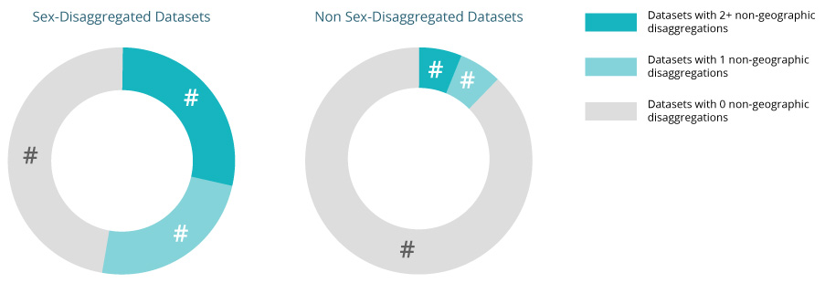

Lorem ipsum dolor sit amet, consectetuer adipiscing elit, sed diam nonummy nibh euismod tincidunt ut laoreet dolore magna aliquam erat volutpat. Ut wisi enim ad minim veniam, quis nostrud exerci tation ullamcorper suscipit lobortis nisl ut aliquip ex ea commodo consequat, vel illum dolore eu feugiat nulla facilisis at vero eros et accumsan et iusto odio dignissim qui blandit praesent luptatum zzril delenit augue duis dolore te feugait nulla facilisi.

**Figure 7: Disaggregation of indicators, 2023**

|  |
| --- |
| **Country Spotlight: [Country Name]**  Lorem ipsum dolor sit amet, consectetuer adipiscing elit, sed diam nonummy nibh euismod tincidunt ut laoreet dolore magna aliquam erat volutpat. Ut wisi enim ad minim veniam, quis nostrud exerci tation ullamcorper suscipit lobortis nisl ut aliquip ex ea commodo consequat, vel illum dolore eu feugiat nulla facilisis at vero eros et accumsan et iusto odio dignissim qui blandit praesent luptatum zzril delenit augue duis dolore te feugait nulla facilisi. |

## Recommendation

|  |
| --- |
| **Lorem ipsum dolor sit amet, consectetuer adipiscing elit, sed diam nonummy nibh euismod tincidunt ut laoreet dolore magna aliquam erat volutpat.** |

Lorem ipsum dolor sit amet, consectetuer adipiscing elit, sed diam nonummy nibh euismod tincidunt ut laoreet dolore magna aliquam erat volutpat. Ut wisi enim ad minim veniam, quis nostrud exerci tation ullamcorper suscipit lobortis nisl ut aliquip ex ea commodo consequat, vel illum dolore eu feugiat nulla facilisis at vero eros et accumsan et iusto odio dignissim qui blandit praesent luptatum zzril delenit augue duis dolore te feugait nulla facilisi.

# [3] How open are gender data?

[Openness elements] are key barriers to gender data accessibility, with [%] of countries lacking it completely. Ensuring that any gender data that are available can subsequently be accessed and used is critical to ensuring that these data will have any impact. Unless the data can be freely downloaded and used for analysis, the data will remain locked away, as if they did not exist at all. Publishing data needs to be about more than just posting a picture of a table or graph online. To make data fully open and accessible, they need to be in an open format so that they can be analyzed using any statistical software. Sufficient metadata must be available to guide users so that the data can be properly understood and used. And the data need to be easily downloadable with customized data selection along with an open license that allows their free use and re-use, even including commercial purposes.

Countries have a responsibility to protect the privacy of individuals about which data are collected, but at the level at which these data are published, the right methods will have fully anonymized them, ensuring that they are safe to widely share. And though it is impossible to control how open gender data are used, sufficient metadata and promoting data literacy within a population will help ensure that the data are not improperly used.

## Lorem ipsum dolor sit amet, consectetuer adipiscing elit

Lorem ipsum dolor sit amet, consectetuer adipiscing elit, sed diam nonummy nibh euismod tincidunt ut laoreet dolore magna aliquam erat volutpat. Ut wisi enim ad minim veniam, quis nostrud exerci tation ullamcorper suscipit lobortis nisl ut aliquip ex ea commodo consequat, vel illum dolore eu feugiat nulla facilisis at vero eros et accumsan et iusto odio dignissim qui blandit praesent luptatum zzril delenit augue duis dolore te feugait nulla facilisi.

**Figure 8: Openness subscores by data category, 2023**

|  |
| --- |
| **Country Spotlight: [Country Name]**  Lorem ipsum dolor sit amet, consectetuer adipiscing elit, sed diam nonummy nibh euismod tincidunt ut laoreet dolore magna aliquam erat volutpat. Ut wisi enim ad minim veniam, quis nostrud exerci tation ullamcorper suscipit lobortis nisl ut aliquip ex ea commodo consequat. |

## Lorem ipsum dolor sit amet, consectetuer adipiscing elit

Lorem ipsum dolor sit amet, consectetuer adipiscing elit, sed diam nonummy nibh euismod tincidunt ut laoreet dolore magna aliquam erat volutpat. Ut wisi enim ad minim veniam, quis nostrud exerci tation ullamcorper suscipit lobortis nisl ut aliquip ex ea commodo consequat.

**Figure 9: Openness elements for all data categories, 2023**

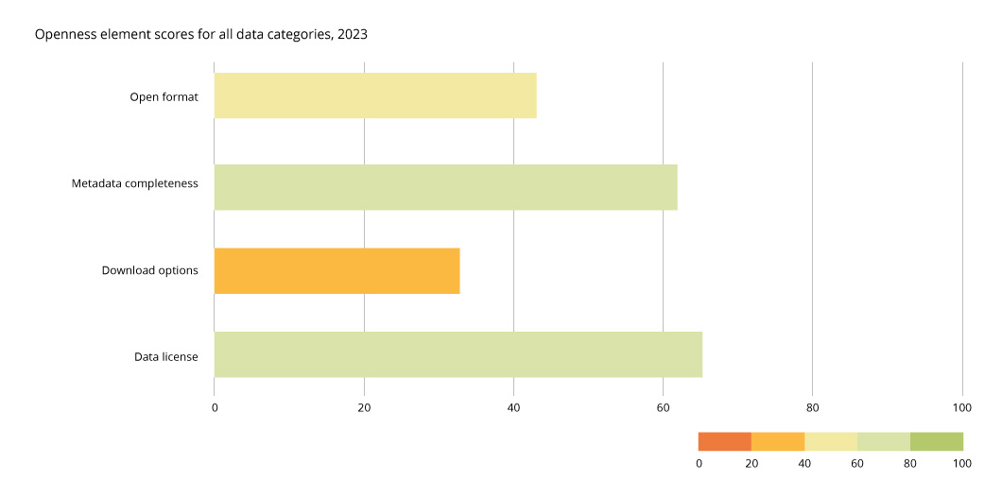

|  |
| --- |
| **Country Spotlight: [Country Name]**  Lorem ipsum dolor sit amet, consectetuer adipiscing elit, sed diam nonummy nibh euismod tincidunt ut laoreet dolore magna aliquam erat volutpat. Ut wisi enim ad minim veniam, quis nostrud exerci tation ullamcorper suscipit lobortis nisl ut aliquip ex ea commodo consequat, vel illum dolore eu feugiat nulla facilisis at vero eros et accumsan et iusto odio dignissim qui blandit praesent luptatum zzril delenit augue duis dolore te feugait nulla facilisi. |

Lorem ipsum dolor sit amet, consectetuer adipiscing elit, sed diam nonummy nibh euismod tincidunt ut laoreet dolore magna aliquam erat volutpat. Ut wisi enim ad minim veniam, quis nostrud exerci tation ullamcorper suscipit lobortis nisl ut aliquip ex ea commodo consequat.

**Figure 10:** **Openness of gender and non-gender data**

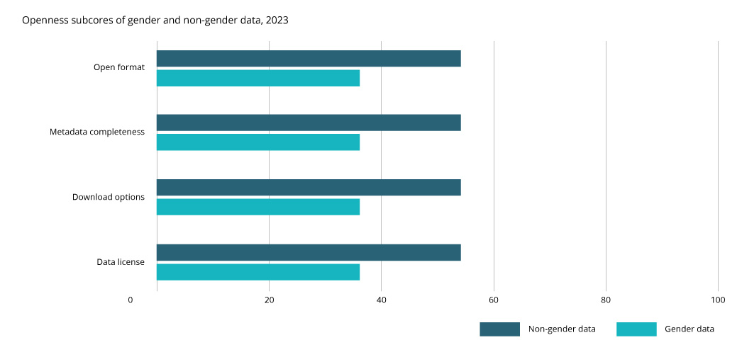

## Recommendation

|  |
| --- |
| **Lorem ipsum dolor sit amet, consectetuer adipiscing elit, sed diam nonummy nibh euismod tincidunt ut laoreet dolore magna aliquam erat volutpat.** |

Lorem ipsum dolor sit amet, consectetuer adipiscing elit, sed diam nonummy nibh euismod tincidunt ut laoreet dolore magna aliquam erat volutpat. Ut wisi enim ad minim veniam, quis nostrud exerci tation ullamcorper suscipit lobortis nisl ut aliquip ex ea commodo consequat, vel illum dolore eu feugiat nulla facilisis at vero eros et accumsan et iusto odio dignissim qui blandit praesent luptatum zzril delenit augue duis dolore te feugait nulla facilisi.

# [4] Do country policies and laws prioritize the production of gender data?

Effective institutional foundations to support the collection, publication, and use of gender data relies on the presence of robust legal, policy, and coordination frameworks. These frameworks not only lay the groundwork, but they also empower national statistical offices (NSOs) to produce and disseminate gender data effectively. And they ensure that gender data collection aligns with broader national development goals and plans. Without them, efforts to make gender data available to those who need them will receive insufficient support and flounder.

## Lorem ipsum dolor sit amet, consectetuer adipiscing elit

Measuring institutional foundations for gender data across countries can be complex, especially as there are many elements that support the production and mainstreaming of gender data. Open Data Watch developed five indicators for measuring institutional foundations across 185 countries:

1. References of gender in existing statistical laws: Finding references of gender in existing statistical laws provides further context on how the national statistical systems and governments recognize gender data.
2. References of coordination in statistical laws: The inclusion of coordination (or related language) in statistical laws indicate that the national statistical office has the mandate to coordinate with other producers of statistics across the government. Existing coordination frameworks pave the way for NSOs to coordinate with other bodies in producing more gender data.
3. Web links from the NSO website to the **gender-relevant ministry**[2] websites: Oftentimes, NSO provide links to other government ministries and bodies, such as ministries of education or health. Website links to the gender-ministry website could indicate that there are linkages between entities.
4. References of data in gender-relevant ministries: This includes statistical yearbooks, data portals, or the inclusion and use of data in gender plans or work programs. This provides a paper trail on coordination or linkages between the gender-relevant ministry, NSO and other statistical producers.
5. References of gender data coordination in NSDS: Finding references of gender data coordination in NSDSs or statistical plans provide further context on how NSOs prioritize gender data and gender data for statistical planning purposes.

Figure 11 provides a breakdown of foundational indicators across all countries. Only 13.2 percent of statistical laws include gender, whereas 94.5 percent of statistical laws include coordination. With having a groundwork for statistical coordination between producers of statistics, NSOs could develop MOUs or inter-agency agreements on gender data. In terms of linkages between the NSO and gender-relevant ministry, only six percent of NSOs provide weblinks to the gender-relevant ministry, but around 70 percent of gender-relevant ministries either have some mention of gender data or have the full integration of gender data in existing policies and work programs. The use of data from gender-relevant ministries indicate some linkages with the NSO and statistical producers. In terms of gender data coordination in NSDSs, 47.3 percent of NSDSs have sporadic efforts to improve gender data such as having line-item tasks on gender data, whereas 12.2 percent of NSDSs fully mainstream and integrate gender.

**Figure 11: Performance of foundational indicators across all countries, 2023**

|  |
| --- |
| **Country Spotlight: [Country Name]**  Lorem ipsum dolor sit amet, consectetuer adipiscing elit, sed diam nonummy nibh euismod tincidunt ut laoreet dolore magna aliquam erat volutpat. Ut wisi enim ad minim veniam, quis nostrud exerci tation ullamcorper suscipit lobortis nisl ut aliquip ex ea commodo consequat, vel illum dolore eu feugiat nulla facilisis at vero eros et accumsan et iusto odio dignissim qui blandit praesent luptatum zzril delenit augue duis dolore te feugait nulla facilisi. |

## Lorem ipsum dolor sit amet, consectetuer adipiscing elit

Lorem ipsum dolor sit amet, consectetuer adipiscing elit, sed diam nonummy nibh euismod tincidunt ut laoreet dolore magna aliquam erat volutpat. Ut wisi enim ad minim veniam, quis nostrud exerci tation ullamcorper suscipit lobortis nisl ut aliquip ex ea commodo consequat, vel illum dolore eu feugiat nulla facilisis at vero eros et accumsan et iusto odio dignissim qui blandit praesent luptatum zzril delenit augue duis dolore te feugait nulla facilisi.

|  |
| --- |
| **Country Spotlight: [Country Name]**  Lorem ipsum dolor sit amet, consectetuer adipiscing elit, sed diam nonummy nibh euismod tincidunt ut laoreet dolore magna aliquam erat volutpat. Ut wisi enim ad minim veniam, quis nostrud exerci tation ullamcorper suscipit lobortis nisl ut aliquip ex ea commodo consequat, vel illum dolore eu feugiat nulla facilisis at vero eros et accumsan et iusto odio dignissim qui blandit praesent luptatum zzril delenit augue duis dolore te feugait nulla facilisi. |

## Lorem ipsum dolor sit amet, consectetuer adipiscing elit

Lorem ipsum dolor sit amet, consectetuer adipiscing elit, sed diam nonummy nibh euismod tincidunt ut laoreet dolore magna aliquam erat volutpat. Ut wisi enim ad minim veniam, quis nostrud exerci tation ullamcorper suscipit lobortis nisl ut aliquip ex ea commodo consequat, vel illum dolore eu feugiat nulla facilisis at vero eros et accumsan et iusto odio dignissim qui blandit praesent luptatum zzril delenit augue duis dolore te feugait nulla facilisi.

|  |
| --- |
| **Country Spotlight: [Country Name]**  Lorem ipsum dolor sit amet, consectetuer adipiscing elit, sed diam nonummy nibh euismod tincidunt ut laoreet dolore magna aliquam erat volutpat. Ut wisi enim ad minim veniam, quis nostrud exerci tation ullamcorper suscipit lobortis nisl ut aliquip ex ea commodo consequat, vel illum dolore eu feugiat nulla facilisis at vero eros et accumsan et iusto odio dignissim qui blandit praesent luptatum zzril delenit augue duis dolore te feugait nulla facilisi. |

# [5] Do countries have the statistical and technical capacity to produce gender data?

The statistical and technical strength necessary to collect, analyze, and use gender data empowers nations to tailor their efforts to inform and address country-specific gender issues. Surveys and censuses are conducted with regular frequency to collect critical information on the well-being of citizens. Administrative systems operate continuously to monitor the real time situation in crucial topics, particularly education, health, and civil registration and vital statistics (CRVS), which covers births, marriages, divorces, and deaths. Without the technical capacity to conduct surveys and census, and maintain administrative data systems, decision-makers are left in the dark without any data to guide critical decisions.

**Figure 12: Core gender data system**

## Lorem ipsum dolor sit amet, consectetuer adipiscing elit

Population and housing censuses enumerate everyone residing in a country. Censuses also collect information about gender, ethnicity, income, education level and other variables of those who are enumerated. Typically conducted every ten years, censuses are critical for evidence-based decision-making on socio-economic issues from education to social services. Censuses can also be used as a baseline to project future populations. With inadequate or infrequent censuses, countries could continue to design policies and programs that may not reach to populations or communities in most need—such as women and girls living in rural or remote areas.

**Figure 13: Availability of censuses, 2023**

|  |
| --- |
| ***Country spotlight: Census and SOGI in the context of Canada***  Lorem ipsum dolor sit amet, consectetuer adipiscing elit, sed diam nonummy nibh euismod tincidunt ut laoreet dolore magna aliquam erat volutpat. Ut wisi enim ad minim veniam, quis nostrud exerci tation ullamcorper suscipit lobortis nisl ut aliquip ex ea commodo consequat, vel illum dolore eu feugiat nulla facilisis at vero eros et accumsan et iusto odio dignissim qui blandit praesent luptatum zzril delenit augue duis dolore te feugait nulla facilisi. |

## Lorem ipsum dolor sit amet, consectetuer adipiscing elit

Lorem ipsum dolor sit amet, consectetuer adipiscing elit, sed diam nonummy nibh euismod tincidunt ut laoreet dolore magna aliquam erat volutpat. Ut wisi enim ad minim veniam, quis nostrud exerci tation ullamcorper suscipit lobortis nisl ut aliquip ex ea commodo consequat, vel illum dolore eu feugiat nulla facilisis at vero eros et accumsan et iusto odio dignissim qui blandit praesent luptatum zzril delenit augue duis dolore te feugait nulla facilisi.

|  |
| --- |
| ***Country spotlight: [Insert survey instrument type]***  Lorem ipsum dolor sit amet, consectetuer adipiscing elit, sed diam nonummy nibh euismod tincidunt ut laoreet dolore magna aliquam erat volutpat. Ut wisi enim ad minim veniam, quis nostrud exerci tation ullamcorper suscipit lobortis nisl ut aliquip ex ea commodo consequat, vel illum dolore eu feugiat nulla facilisis at vero eros et accumsan et iusto odio dignissim qui blandit praesent luptatum zzril delenit augue duis dolore te feugait nulla facilisi. |

**Figure 14: Availability of surveys to collect gender data, 2023**

*Select survey from the drop-down box to view.*

## Lorem ipsum dolor sit amet, consectetuer adipiscing elit

Lorem ipsum dolor sit amet, consectetuer adipiscing elit, sed diam nonummy nibh euismod tincidunt ut laoreet dolore magna aliquam erat volutpat. Ut wisi enim ad minim veniam, quis nostrud exerci tation ullamcorper suscipit lobortis nisl ut aliquip ex ea commodo consequat, vel illum dolore eu feugiat nulla facilisis at vero eros et accumsan et iusto odio dignissim qui blandit praesent luptatum zzril delenit augue duis dolore te feugait nulla facilisi.

**Figure 15: Availability of data produced by administrative systems, 2023**

|  |
| --- |
| ***Country spotlight: CRVS in a country***  Lorem ipsum dolor sit amet, consectetuer adipiscing elit, sed diam nonummy nibh euismod tincidunt ut laoreet dolore magna aliquam erat volutpat. Ut wisi enim ad minim veniam, quis nostrud exerci tation ullamcorper suscipit lobortis nisl ut aliquip ex ea commodo consequat, vel illum dolore eu feugiat nulla facilisis at vero eros et accumsan et iusto odio dignissim qui blandit praesent luptatum zzril delenit augue duis dolore te feugait nulla facilisi. |

## Lorem ipsum dolor sit amet, consectetuer adipiscing elit

Lorem ipsum dolor sit amet, consectetuer adipiscing elit, sed diam nonummy nibh euismod tincidunt ut laoreet dolore magna aliquam erat volutpat. Ut wisi enim ad minim veniam, quis nostrud exerci tation ullamcorper suscipit lobortis nisl ut aliquip ex ea commodo consequat, vel illum dolore eu feugiat nulla facilisis at vero eros et accumsan et iusto odio dignissim qui blandit praesent luptatum zzril delenit augue duis dolore te feugait nulla facilisi.

**Figure 16: Governments’ ICT capacity compared to their GDC Openness score.**

Source: UN EGDI data.

Lorem ipsum dolor sit amet, consectetuer adipiscing elit, sed diam nonummy nibh euismod tincidunt ut laoreet dolore magna aliquam erat volutpat. Ut wisi enim ad minim veniam, quis nostrud exerci tation ullamcorper suscipit lobortis nisl ut aliquip ex ea commodo consequat, vel illum dolore eu feugiat nulla facilisis at vero eros et accumsan et iusto odio dignissim qui blandit praesent luptatum zzril delenit augue duis dolore te feugait nulla facilisi.

# [6] Do countries have funds allocated specifically to produce more gender data?

Sufficient funding, both at the domestic and international levels, is pivotal for the sustainability of gender data systems. International donors are crucial to supporting the development and strengthening of emerging statistical systems while sufficient domestic funding reflects the prioritization of political will and results in robust and sustainable data systems. Such investments are vital for advancing gender equality, as they enable the collection, analysis, dissemination, and use of critical gender data, underpinning evidence-based policymaking and the pursuit of equitable development.

## Lorem ipsum dolor sit amet, consectetuer adipiscing elit

Lorem ipsum dolor sit amet, consectetuer adipiscing elit, sed diam nonummy nibh euismod tincidunt ut laoreet dolore magna aliquam erat volutpat. Ut wisi enim ad minim veniam, quis nostrud exerci tation ullamcorper suscipit lobortis nisl ut aliquip ex ea commodo consequat, vel illum dolore eu feugiat nulla facilisis at vero eros et accumsan et iusto odio dignissim qui blandit praesent luptatum zzril delenit augue duis dolore te feugait nulla facilisi.

**Figure 17: Availability of budget information for gender data, 2023**

## Lorem ipsum dolor sit amet, consectetuer adipiscing elit

Lorem ipsum dolor sit amet, consectetuer adipiscing elit, sed diam nonummy nibh euismod tincidunt ut laoreet dolore magna aliquam erat volutpat. Ut wisi enim ad minim veniam, quis nostrud exerci tation ullamcorper suscipit lobortis nisl ut aliquip ex ea commodo consequat, vel illum dolore eu feugiat nulla facilisis at vero eros et accumsan et iusto odio dignissim qui blandit praesent luptatum zzril delenit augue duis dolore te feugait nulla facilisi.

**Figure 18: Distribution of international financing for gender data, [DATA YEAR]**

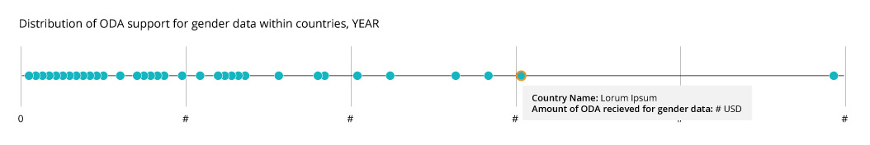

Source: PRESS 2023 data.

Lorem ipsum dolor sit amet, consectetuer adipiscing elit, sed diam nonummy nibh euismod tincidunt ut laoreet dolore magna aliquam erat volutpat. Ut wisi enim ad minim veniam, quis nostrud exerci tation ullamcorper suscipit lobortis nisl ut aliquip ex ea commodo consequat, vel illum dolore eu feugiat nulla facilisis at vero eros et accumsan et iusto odio dignissim qui blandit praesent luptatum zzril delenit augue duis dolore te feugait nulla facilisi.

|  |
| --- |
| **Country Spotlight: Transparency of NSDS budgeting**  Lorem ipsum dolor sit amet, consectetuer adipiscing elit, sed diam nonummy nibh euismod tincidunt ut laoreet dolore magna aliquam erat volutpat. Ut wisi enim ad minim veniam, quis nostrud exerci tation ullamcorper suscipit lobortis nisl ut aliquip ex ea commodo consequat, vel illum dolore eu feugiat nulla facilisis at vero eros et accumsan et iusto odio dignissim qui blandit praesent luptatum zzril delenit augue duis dolore te feugait nulla facilisi. |

# [7] Call to action

Lorem ipsum dolor sit amet, consectetuer adipiscing elit, sed diam nonummy nibh euismod tincidunt ut laoreet dolore magna aliquam erat volutpat. Ut wisi enim ad minim veniam, quis nostrud exerci tation ullamcorper suscipit lobortis nisl ut aliquip ex ea commodo consequat, vel illum dolore eu feugiat nulla facilisis at vero eros et accumsan et iusto odio dignissim qui blandit praesent luptatum zzril delenit augue duis dolore te feugait nulla facilisi.

**[icon] Data Availability: Recommendation title that is punchy and memorable.**

A brief explanation of what this entails. Lorem ipsum dolor sit amet, consectetuer adipiscing elit, sed diam nonummy nibh euismod tincidunt ut laoreet dolore magna aliquam erat volutpat. Im qui blandit praesent luptatum zzril delenit.

**[icon] Data Openness: Recommendation title that is punchy and memorable.**

A brief explanation of what this entails. Lorem ipsum dolor sit amet, consectetuer adipiscing elit, sed diam nonummy nibh euismod tincidunt ut laoreet dolore magna aliquam erat volutpat. Im qui blandit praesent luptatum zzril delenit.

**[icon] Institutional Foundation: Recommendation title that is punchy and memorable.**

A brief explanation of what this entails. Lorem ipsum dolor sit amet, consectetuer adipiscing elit, sed diam nonummy nibh euismod tincidunt ut laoreet dolore magna aliquam erat volutpat. Im qui blandit praesent luptatum zzril delenit.

**[icon] Capacity: Recommendation title that is punchy and memorable.**

A brief explanation of what this entails. Lorem ipsum dolor sit amet, consectetuer adipiscing elit, sed diam nonummy nibh euismod tincidunt ut laoreet dolore magna aliquam erat volutpat. Im qui blandit praesent luptatum zzril delenit.

**[icon] Financing: Recommendation title that is punchy and memorable.**

A brief explanation of what this entails. Lorem ipsum dolor sit amet, consectetuer adipiscing elit, sed diam nonummy nibh euismod tincidunt ut laoreet dolore magna aliquam erat volutpat. Im qui blandit praesent luptatum zzril delenit.

1. Lorem ipsum dolor sit amet, consectetuer adipiscing elit, sed diam nonummy nibh euismod tincidunt ut laoreet dolore magna aliquam erat volutpat. Ut wisi enim ad minim veniam, quis nostrud exerci tation ullamcorper suscipit lobortis nisl ut aliquip.
2. “Gender-relevant ministry” is classified as any government body responsible for gender equality or gender affairs.